GRADE 7 ACCELERATED · UNIT 1  Practice Test  Equations and Inequalities ANSWER KEY | 21 points

DIRECTIONS. Show your work for every question. Write repeating decimals with a bar over the digits that repeat. Fractions do not have to be in simplest form. Where a question gives units, include them in your answer.
READ THIS FIRST. This practice test is the test — same twelve questions, same order, same point values, only the numbers are different. Nothing on the test will look like anything you have not seen here.
 | What it covers | Questions | Points
A | Equivalent forms of rational numbers | 1, 2 | 7
B | Writing and solving an equation from a situation | 3, 7 | 4
C | Solving two-step equations | 4, 5, 6 | 3
D | Deciding whether a value solves an inequality | 8 | 1
E | Solving and graphing inequalities | 9, 10, 11 | 3
F | An inequality in a real-world situation | 12 | 3

1. Complete the table by writing the equivalent value in each empty cell. | MA.7.NSO.1.2  3 points

 | Fraction | Decimal | Percent
a. | 5/9 | 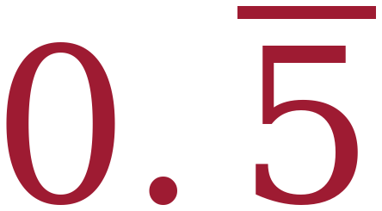 | 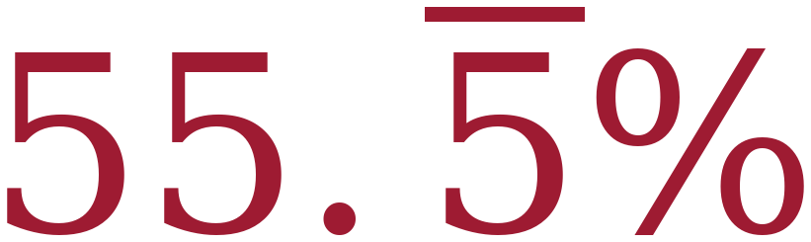
b. | 65/100 (or 13/20) | 0.65 | 65%
c. | 48/100 (or 12/25) | 0.48 | 48%

One point per row, and both empty cells in a row have to be right. Any equivalent fraction is fine. A repeating decimal written without the bar does not earn the row.
2. Devon opens a bag of fruit chews with five flavors. The table shows what part of the bag is each flavor. | MA.7.NSO.1.2  4 points

Flavor | Amount
Cherry | 25%
Grape | 7/45
Lemon | 0.15
Orange | 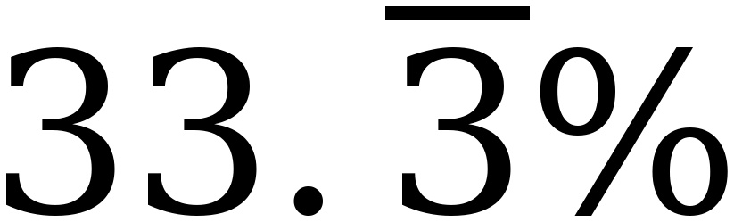
Berry | 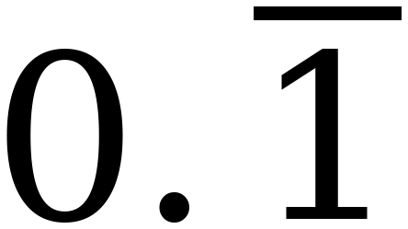

a. What percentage of the bag is Lemon? 1 point |  |  | b. Rewrite the amount that is Grape as a decimal. 1 point
Percentage | 15% |  | Decimal | 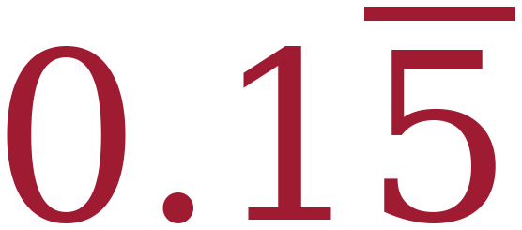

c. What fraction of the bag is Berry? 1 point |  |  | d. Rewrite the amount that is Cherry as a decimal. 1 point
Fraction | 1/9 |  | Decimal | 0.25

No partial credit on any part. 7/45 = 0.15555… so the bar goes over the 5 only, and it is not the same number as Lemon’s 0.15 — worth saying out loud. The five amounts total exactly 100%, which is a good check.
3. Rashad is saving for a summer camp. He is paid the same amount every week. Each week he uses $415 of his pay for expenses and saves everything that is left. After 9 weeks he has saved $423. | MA.7.AR.2.2  2 points

a. Write an equation that can be used to determine the amount, x, in dollars that Rashad is paid each week. | MA.7.AR.2.2  1 point

 | Equation | 9(x − 415) = 423

b. Solve the equation. | MA.7.AR.2.2  1 point

9(x − 415) ÷ 9 = 423 ÷ 9
x − 415 = 47
x = 462
Check: 9(462 − 415) = 9(47) = 423 ✓

 | Solution | x = 462, so Rashad is paid $462 each week

Dividing by 9 first is shortest. Distributing to 9x − 3,735 = 423 is equally correct and earns the point.
Solve each equation. Show your work.
4. −6(w + 5) = 96  MA.7.AR.2.2 1 point  −6(w + 5) ÷ (−6) = 96 ÷ (−6)  w + 5 = −16  w = −21  Check: −6(−21 + 5) = −6(−16) = 96 ✓ |  |  | 5. n ÷ (−4) + 2.6 = −5.9  MA.7.AR.2.2 1 point  n ÷ (−4) = −8.5  n = −8.5 × (−4)  n = 34  Check: 34 ÷ (−4) = −8.5,  and −8.5 + 2.6 = −5.9 ✓ |  |  | 6. 2 ⅚ = 7 ¼ − k  MA.7.AR.2.2 1 point  Common denominator 12: 2⅚ = 34/12 and 7¼ = 87/12  34/12 = 87/12 − k  k = 87/12 − 34/12 = 53/12 = 4 5/12  Check: 87/12 − 53/12 = 34/12 = 2⅚ ✓
Solution | w = −21 |  | Solution | n = 34 |  | Solution | k = 4 5/12, or 53/12

4: distributing first also works — −6w − 30 = 96, so −6w = 126 and w = −21. 5: the last step multiplies by −4, so the answer is POSITIVE; n = −34 is the common error. 6: a sixth has no exact decimal, so this pair cannot both be converted and it is done over a common denominator instead — the same as the unit assessment’s question 6. The unknown is subtracted, so k = 7¼ − 2⅚, not the other way round; as a decimal 53/12 is 4.41666…, so it needs the bar over the 6.
7. A server at the Lakeside Diner earns $9.40 per hour plus $64.60 in tips. | MA.7.AR.2.2  2 points

a. Write an equation that can be used to determine the number of hours, h, the server worked to earn $135.10. | MA.7.AR.2.2  1 point

 | Equation | 9.40h + 64.60 = 135.10

b. Solve the equation. | MA.7.AR.2.2  1 point

9.40h = 70.50 (subtract 64.60 from both sides)
h = 70.50 ÷ 9.40
h = 7.5
Check: 9.40(7.5) + 64.60 = 70.50 + 64.60 = 135.10 ✓

 | Solution | h = 7.5 hours

The tips are a one-time amount, so they are added once, not multiplied by h.
8. Circle every value below that is a solution to −2x + 5 ≥ 17 . | MA.8.AR.2.2  1 point

◯ −11 | ◯ −6⅓ | ◯ −6 | −5 | 0 | 4

−2x + 5 ≥ 17 gives −2x ≥ 12, and dividing by −2 REVERSES it: x ≤ −6. So −11, −6⅓ and −6 are the three solutions — marked here in red. −6 counts because the symbol has the equal bar: −2(−6) + 5 = 17, and 17 ≥ 17. A student who circles −6, −5, 0 and 4 solved without reversing — that set is the endpoint plus everything on the wrong side of it.
Solve each inequality. Show your work, then graph the solution set on the number line.
9. −9.7 > −2x − 1.3 | MA.8.AR.2.2  1 point

−8.4 > −2x (add 1.3 to both sides)
4.2 < x, so x > 4.2 (divide by −2 and REVERSE)
Check: x = 6 gives −13.3, and −9.7 > −13.3 ✓; x = 0 gives −1.3, and −9.7 > −1.3 ✗

 | Solution | x > 4.2

Open circle just past 4, shaded right. The solution and its graph are one point together — a right answer with a wrong graph does not earn it.

10. ⅔ (18 − 15x) > 64 | MA.8.AR.2.2  1 point

18 − 15x > 96 (multiply both sides by 3/2 — no reversal)
−15x > 78
x < −5.2 (divide by −15 and REVERSE)
Check: x = −6 gives ⅔(108) = 72, and 72 > 64 ✓; x = 0 gives 12, and 12 > 64 ✗

 | Solution | x < −5.2

Open circle just left of −5, shaded left. The solution and its graph are one point together.

11. −6(4x + 7) ≥ 150 | MA.8.AR.2.2  1 point

4x + 7 ≤ −25 (divide both sides by −6 and REVERSE)
4x ≤ −32
x ≤ −8
Check: x = −8 gives −6(−25) = 150, and 150 ≥ 150 ✓; x = 0 gives −42, and −42 ≥ 150 ✗

 | Solution | x ≤ −8

Closed circle at −8, shaded left. Distributing first also works: −24x − 42 ≥ 150, so −24x ≥ 192 and x ≤ −8. One reversal either way.

12. The chess club is renting a van for a tournament. The rental company charges a flat fee of $180 plus $16 for each student who rides. The club has raised $700 and wants to take as many students as possible. | MA.8.AR.2.2  3 points

a. Write an inequality that can be used to determine the number of students, s, who can ride the van. | MA.8.AR.2.2  1 point

 | Inequality | 180 + 16s ≤ 700

“Has raised $700” sets a ceiling, so the symbol is ≤. 16s + 180 ≤ 700 is the same thing. A strict < does not earn the point — it would forbid spending exactly $700, which the club is allowed to do, and the symbol is what this part is asking for.
b. Solve the inequality. | MA.8.AR.2.2  1 point

16s ≤ 520 (subtract 180 from both sides)
s ≤ 32.5

 | Solution | s ≤ 32.5

c. How many students can ride? Justify your answer mathematically. | MA.8.AR.2.2  1 point

32 students.
Students come in whole numbers, so round DOWN, not to the nearest whole number.
32 students: 180 + 16(32) = 180 + 512 = $692, which is under $700 ✓
33 students: 180 + 16(33) = 180 + 528 = $708, which is over $700 ✗

Rounding 32.5 to 33 is the error this question is built to catch. The justification has to name a number, not just say “you can't have half a student.”

Marking this paper
One point per lettered part, and one point per question that has no parts. Every part is right or it is not, so the score is a count of ticks and the paper is out of 21 — the same 21 as the unit assessment, question for question.
Follow-through. If a student writes the wrong equation or inequality in one part and then works their own answer correctly in the next, the next part still earns its point. Mark the second part against what they wrote, not against the key.

